Assignment E: Job Pitch
The job pitch was also an useful part of the training sessions. We had to present ourselves to a board of directors in 3 to 4 minutes to convince them that you are the perfect candidate for the job. Off course it wasn’t a real job interview, so u can’t really compare it with a real application, but just like in a real job interview, you had to show your professional skills and unique selling points.

What this job interview eventually was all about, was to show your cultural awareness for the chosen company. In order to work abroad, it is crucial to understand the norms and values of the certain country/company. Because I have analyzed the culture of the UK and I’m about to finish my sportmarketing study , I have chosen for a Marketing manager application. The job pitch went well and I am glad the company hired me.

You can find my job pitch and vacancy in the attachment.
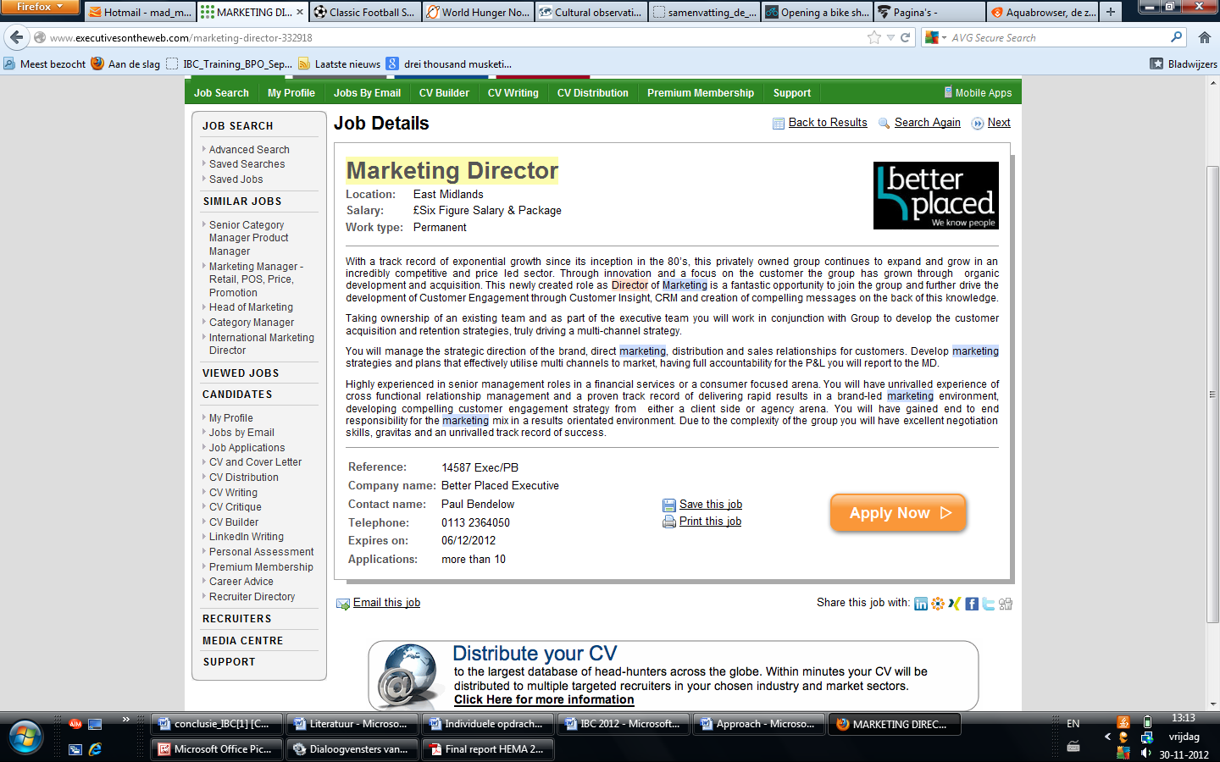
Marketing manager;
Because of the many experience I received in the past 4 years at school, i think i am suitable for the marketing job for the following reasons. I have studied sportmarketing at the HvA at Amsterdam and in order to finish my study, I had to wrote a lot of successful marketing plans for different companies. I had to do this with fellow teammates, also from different cultures, so i know how to work in groups with different Cultures.
I can say I like to work in groups, because you can learn from each other’s insight and knowledge. I think a good teamspirit is essential for the quality of the teamwork. In order to create a good teamspirit I always suggest to get out for a dinner or a drink. On this way you will get to know each other better and can learn from each other’s norms and values, which is important to pay attention. each other strengths and weaknesses.
Because of my marketing experience, good teamwork and great discipline i know i can handle the job. So if you want a ambitious man full with energy, you have the right person in front of you!
USP: Discipline, Social, Good Teamworker

